MedServe User Manual

2021

Table of Contents

1. **ABOUT THIS DOCUMENT 4**

Intended Audience……………….…………………………………………………………………………………………….4

System Requirements……………………………….………………………………………………………………………..4

1. **SOFTWARE DESCRIPTION 5**

Description…………………………….…………………………………………………………………………………………..5

Benefits & Values……………………………………………………………………………………………………………….5

1. OVERVIEW OF THE MEDSERVE SOFTWARE 6

Connecting to the MedServe System………………………………………………………………………………….6

***Login Screen*** …………………………………………..………………………………………..…………………………………7

Login with Badge………………………………………………………………………………………………….……...7

Username & Password………………………………………………………………………………………………...8

***Patient Record***….…………………………………………………………………………………………………………………9

All Patients………………….……………………………………………………………………………………………….9

My Patients………………………………………………………………………………………………………………..16

Add Patient………………………………………………………………………………………………………………..17

***Inventory***…………………………………………………………….…………………………………………………………….18

Ad Hoc Dispense……………..…………………………………………………………………………………………18

End of Shift Count……………………..……………………………………………………………………………….19

Configure Inventory………….………………..……………………………………………………………………..20

Waste…………………………………………………………………………………………………………………….….22

***Reports***……………………………………………………..………………………………………………………………………23

***Discrepancies***……….……………………………………………………………………………………………………………24

Resolve………………………………………………………………………………………………………………………25

***Import/Export***………………….………………………………………………………………………………………………..26

***Pharmacy***………………………………………………………………………………………………………………………....27

***Settings***…………………………………………………………………………………………………………………………….28

Users Settings………..…………………………………………………………………………………………………28

Discharge / Admit…………………………………………………………………………………………………….29

Edit Rooms / Beds…………………………………………………………………………………………………….31

Admin Settings……….…………………………………………………………………………………….........….33

Physician Settings…………………………………………………………………………………………………….34

1. **USING THE MEDSERVE SOFTWARE 35**

Nurses, Supervisors, and Administrators**….…………………………………..…………………………....…**35

1. **TROUBLESHOOTING AND SUPPORTING DOCUMENTS 43**

Additional Support Documents…………..……………………………………………………………………………43

Troubleshooting………………………………………………………………………………………………………………44

1. APPENDIX A: IMPORTING DATA 46
2. APPENDIX B: BYTESCOUT BARCODE GENERATOR 51
3. **GLOSSARY 54**
4. **INDEX 56**

# About this document

1

The MedServe software is a tool for creating, modifying, dispensing, analyzing, and reporting medical data in a simulated environment.

Learning to use this software is quick and easy. This user guide presents an overview of the software’s features and gives step-by-step instructions for completing various tasks.

# **Intended Audience**

This manual is intended for nursing students, faculty, and others working with the MedDispense Automated Dispensing Cabinets. This manual provides answers to specific features and procedures that you’ll need to operate the MedServe software successfully.

# **System Requirements**

Please ensure that your computer meets or exceeds the following system requirements before running the MedServe software.

Table 1-1 System Requirements

|  |  |
| --- | --- |
|  |  |
| Processor | One gigahertz (GHz) or faster processor |
| Operating System | Windows 10 |
| Storage | 2GB for a 64-bit processor |
| Graphics Card | DirectX 9 or later with WDDM 1.0 driver |
| Display | 800x600 |
| Scanner (Optional) | Tera Barcode Scanner Wireless 1D 2D 2-in-1 |

# Software Description

2

# **Description**

The MedServe software is a tool designed to be compatible with MedDispense Automated Dispensing Cabinets and simulate practical, medical dispensing procedures for patients in a real-world setting. The MedDispense Automated Dispensing Cabinets are used for inventory, medication management, and to better patient and caregiver experience. The MedServe software is an interactive dispensing system that contains a complete graphical user interface of this medical dispensing process. It includes features that will accurately manage your patients and medication in a simulated setting. The MedServe software can create and store users, patients, rooms, and physician information into an SQLite database and retrieve medication information from the CSIS server that runs RXNav-in-a-Box from Docker. The MedServe software features a set of permission levels that new users can be assigned for the login and dispensing process. Each user will be allowed to administer medication from the MedDispense Automated Dispensing Cabinets to selected patients.

# **Benefits and Values**

* The MedServe software provides a unique medical dispensing experience for nursing students, faculty, and others working with the MedDispense Automated Dispensing Cabinets.
* The MedServe software provides an easy-to-use user interface and demonstrates the core functionality of a Med-cart Dispense System.
* The MedServe software offers a clean design and allows you to configure the system to meet operational needs.

# Overview of the MedServe Software

3

# **Connecting to the MedServe System**

Note: Please turn on the Medcart Dispensing Automated Cabinets before launching the MedServe application. If you are starting this application for the first time or changing the database file, please follow the instructions below.

*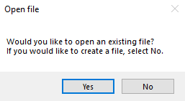MedServe Database File Storage Path*

1. Locate and create .db files within **C:\Users\Public\Public Documents\MedServe.**

*Selecting New Database*

1. Click on the MedServe application icon on your Desktop.
2. 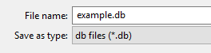Create a new database file to use for *Figure 3-1* by selecting “**No.**”

*Figure 3-1*

1. Name and save the new database file with the type (db files (*.db)) within **C:\Users\Public\Public Documents\MedServe** as shown in *Figure 3-2*.
2. Login using the **username:** MedServeAdmin and **password:** Admin@MedServe1 or using the **barcode:** hiu678kjigUYtuijkg6%#.

*Figure 3-2*

**Note: Please change your password and barcode before using the system’s functionality.**

*Selecting Existing Database*

1. Click on the MedServe application icon on your Desktop.
2. Select a database file to use *Figure 3-1* by selecting “**Yes.**”
3. Choose a .db file within the **C:\Users\Public\Public Documents\MedServe** and click “**Open.**”
4. Login by scanning your badge ID or enter a username and password by clicking “**Login with Password.**”

**MedServe Default Settings:**

COM port: **COM1**

Simulation mode: **Off**

Baud rate: **115200**

Drawers: **Empty**

# Login Screen: Login with Badge

*Figure 3-3.* This login screen gives the user the option to log on by scanning a barcode or QR code.

**1**

**3**

**2**

|  |  |
| --- | --- |
|  |  |
| 1. Scan ID Card: | Use the scanner to scan your badge ID card into the textbox. |
| 2. Login: | Use this button to login once the badge ID appears in the textbox. |
| 3. Login with Password: | Use this button to login using a username and password instead. |

Table 3-1: Figure 3-3 Details

# Login Screen: Username & Password

**3**

**2**

**4**

**1**

**4**

*Figure 3-4.* This login screen gives the user the option to log on using a assigned username and password.

|  |  |
| --- | --- |
|  |  |
| 1.Username: | Use this text box to input the username or ID assigned to you. |
| 2. Password: | Use this text box to input the password assigned to you. |
| 3. Login: | Use this button once both username and password are entered. |
| 4. Log with Badge: | Use this button to login using a barcode or QR code instead. |

Table 3-2: Figure 3-4 Details

# Patient Records: All Patients

**12**

**2**

*Figure 3-5.* This patient records screen allows the user to select a patient to dispense medication to, search a patient by their first and last name, and create a new patient.

Table 3-3: Figure 3-5 Details

|  |  |
| --- | --- |
|  |  |
| 1. Search Bar: | Type a patient’s name or MRN in the search bar to find their record. |
| 2. Patient Selection: | Select a patient record to continue towards the dispensing process. |

# Patient Records: All Patients 🡪 Selected Patient

**1**

**22**

**3**

*Figure 3-6*.This patient selection screen allows the user to edit and save patient demographic information, add / edit allergies, and dispense medication to the selected patient.

**4**

|  |  |
| --- | --- |
|  |  |
| 1. Add / Edit Allergies: | Use this button to add or edit an allergy to the patient’s record. |
| 2. Edit Patient: | Use this button to change and save the patient demographic information. |
| 3. Medication Selection: | Select a medication from prescriptions to dispense. Note: Override sign-off is required for medicines that interact with specific allergies or other medication. |
| 4. Trash: | Use this button ( ) to remove a prescription from the prescriptions table.  Click ✔ to remove prescription.  Click **X** to cancel the action. |

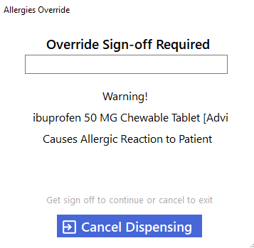

Table 3-4: Figure 3-6 Details

*Figure 3-7:* Allergy Override for specific medications

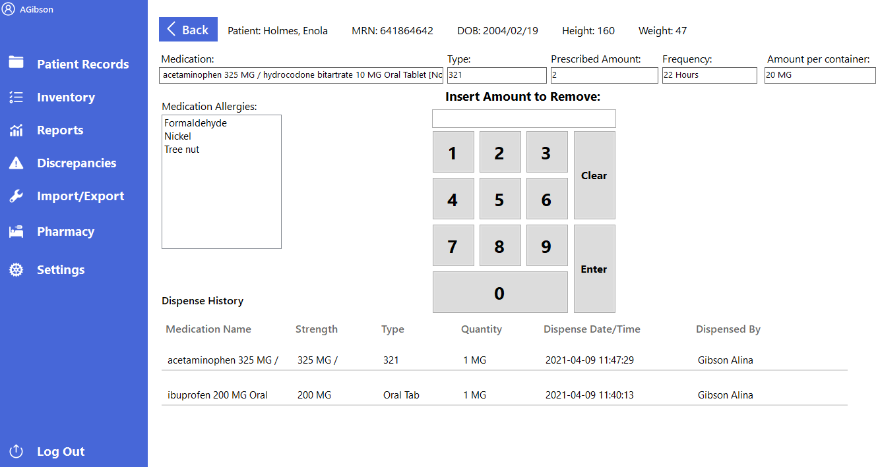Patient Records: All Patients 🡪 Selected Patient 🡪 Select Medication

**2**

**1**

*Figure 3-8.* This dispense medication screens allows the user to view a patient’s demographic, medical history, and allergies before dispensing to the selected patient.

|  |  |
| --- | --- |
|  |  |
| 1. Amount to Remove: | Use the text box to enter the amount of medication to remove from the drawer. |
| 2. Number Pad: | Use these buttons to input a number into the text box above and press “**Enter”** to open the drawer. |

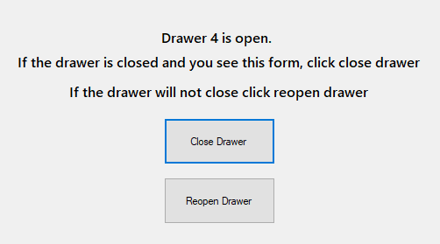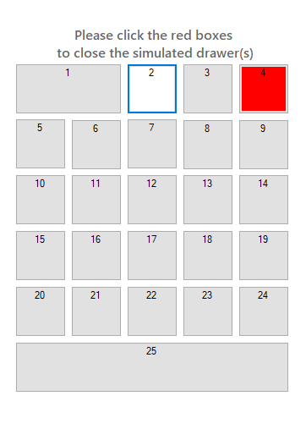

Table 3-5: Figure 3-8 Details

*Figure 3-10:* Appears when Simulation mode is enabled



*Figure 3-9:* Appears when Simulation mode is disabled

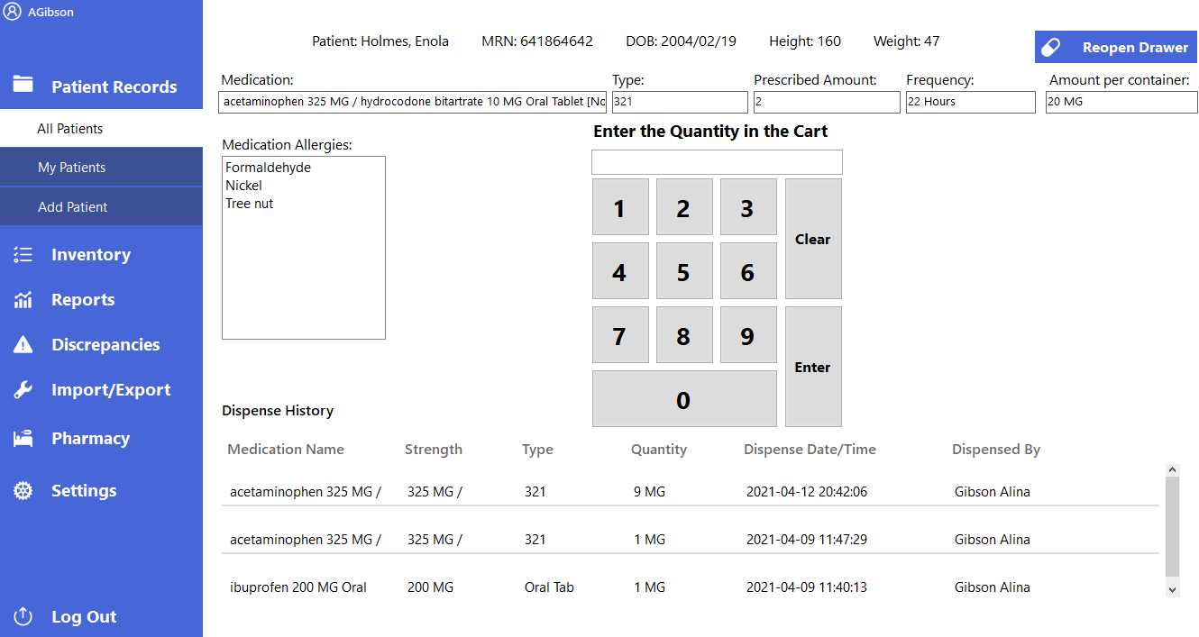Patient Records: All Patients 🡪 Selected Patient 🡪 Select Medication

**1**

**3**

**2**

*Figure 3-11.* This dispense medication screens allows the user to view a patient’s demographic, dispense history, allergies, and enter the medication quantity for the selected medication (narcotic / controlled).

|  |  |
| --- | --- |
|  |  |
| 1. Reopen Drawer: | Use this button to reopen the medication drawer. |
| 2. Quantity in the Cart: | Use the text box to enter the quantity of the medication within the drawer. |
| 2. Number Pad: | Use these buttons to input a number into the text box above and press “**Enter”** to save the medication’s quantity into the system. |

Table 3-6: Figure 3-11 Details

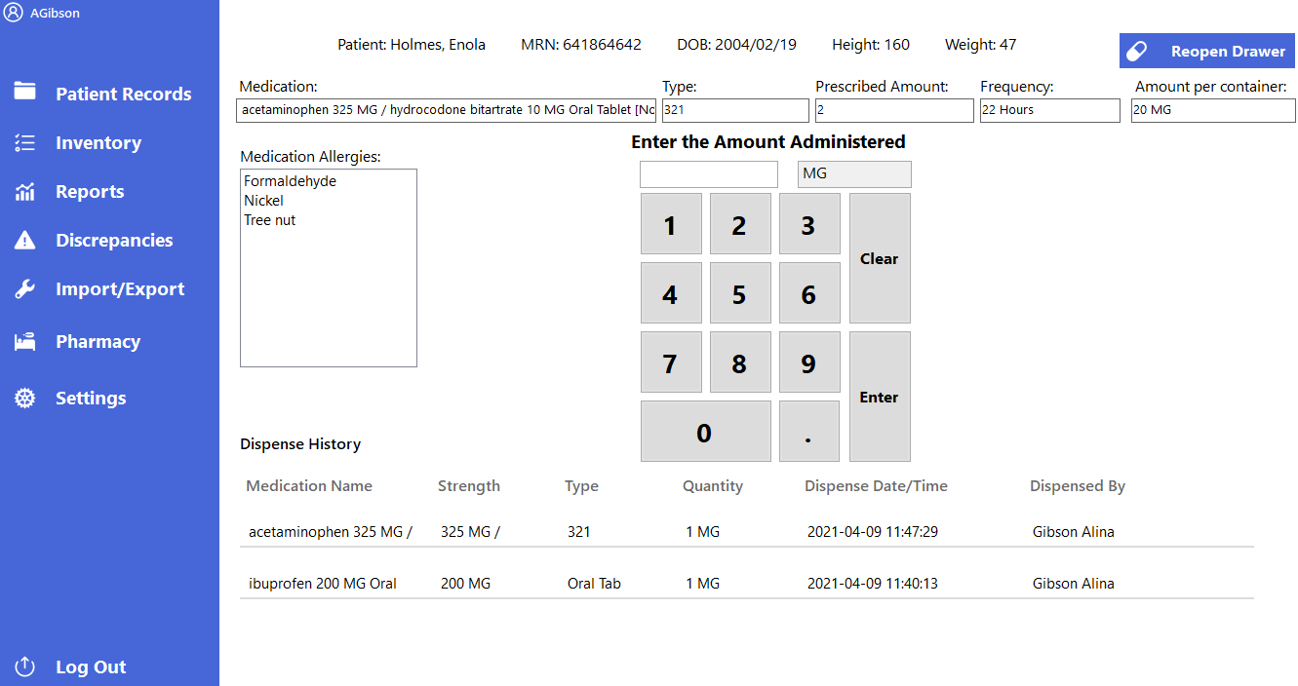Patient Records: All Patients 🡪 Selected Patient 🡪 Select Medication

**2**

**3**

**1**

*Figure 3-12.* This dispense medication screens allows the user to view a patient’s demographic, dispense history, allergies, and enter the medication amount administered for the selected medication.

|  |  |
| --- | --- |
|  |  |
| 1. Reopen Drawer: | Use this button to reopen the medication drawer. |
| 2. Amount Administered: | Use the text box to enter the amount administered of the selected medication in the drawer. |
| 3. Number Pad: | Use these buttons to input a number into the text box above and press “**Enter”** to save the amount administered into the system. |

Table 3-7: Figure 3-12 Details

Patient Records: All Patients 🡪 Selected Patient 🡪 Selected Medication 🡪 Submit Amount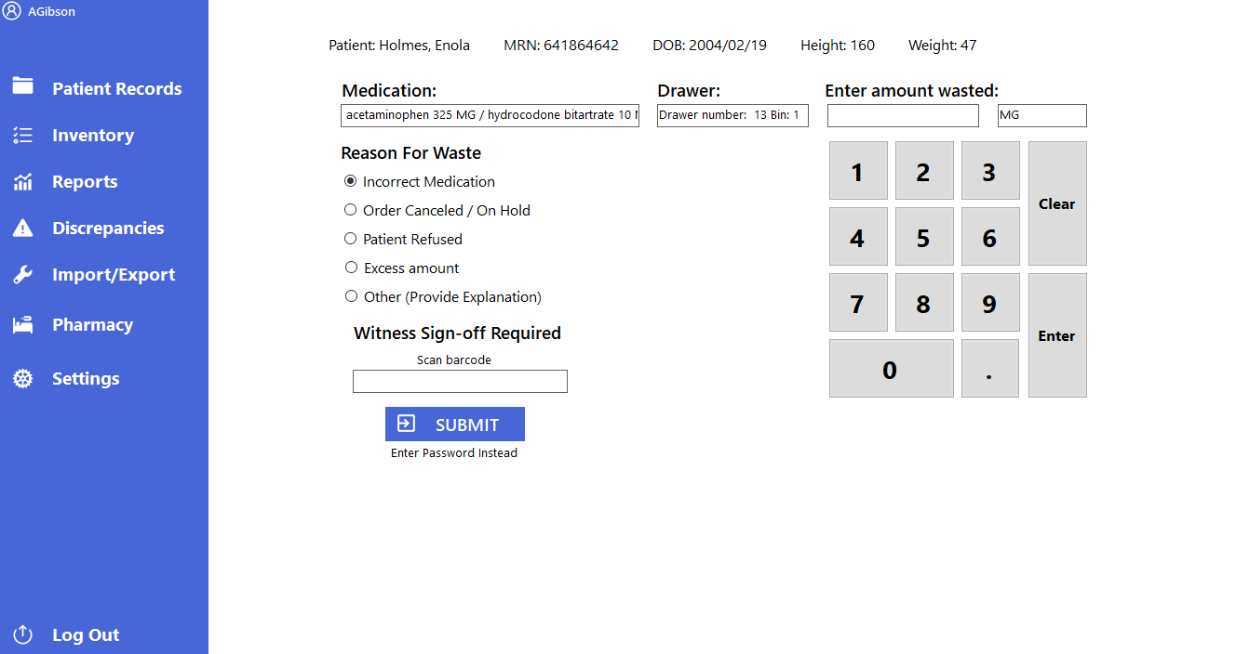

**5**

**4**

**3**

**2**

**1**

*Figure 3-13.* This waste screen allows the user to waste medication after the dispensing process. A witness sign-off is required for narcotics / controlled medications.

|  |  |
| --- | --- |
|  |  |
| 1. Enter Amount Waste: | Use this text box to enter the wasted amount of medication. |
| 2. Reason for Waste: | Use these radio buttons to provide a reason for wasting the selected medication. |
| 3. Witness Sign-Off Required: | Use these text boxes to insert a username and password or a barcode for the witness sign-off requirement. |
| 4. Submit: | Use this button to waste the medication. |
| 5. Number Pad: | Use these buttons to input a number into the text box above and press “**Enter”** to save the amount wasted into the system. |

Table 3-8: Figure 3-13 Details

Patient Records: All Patients 🡪 Selected Patient 🡪 Add Allergies

**3**

**6**

**5**

**1**

**4**

**2**

*Figure 3-14.* This add allergies screens allows the user to select from a list of known allergies and add that allergy to a patient’s medical history.

|  |  |  |  |
| --- | --- | --- | --- |
|  |  |  |  |
| 1. Add Allergy: | Use this button to add an allergy to the allergy table. | **4. Allergy Type:** | Select from a list of known allergy types (e.g., food, environment, drugs). |
| 2. Allergy Name: | Select from a list of recently added allergies or enter an allergy name into the textbox. | **5. Pencil:** | Use this button ( 🖉 ) to edit an allergy from the allergy table. |
| 3. Allergy Severity: | Select from a list of allergy severity classes levels (1-5) or not applicable. | **6. Trash:** | Use this button ( )to remove an allergy from the allergy table.  Click ✔ to remove.  Click **X** to cancel the action. |

Table 3-9: Figure 3-14 Details

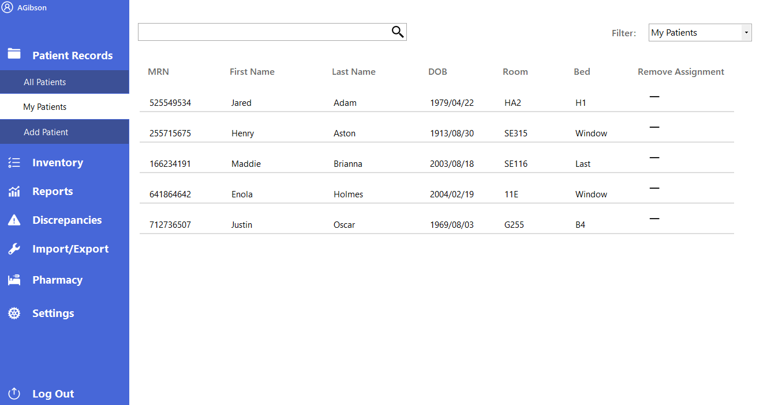Patient Records: My Patients

**4**

**3**

**2**

**1**

*Figure 3-15.* This my patients screen allows the user to remove and assign patients for the dispensing process.

|  |  |  |  |
| --- | --- | --- | --- |
|  |  |  |  |
| 1. Search Bar: | Type a patient’s name or MRN in the search bar to find their record. | **3. Patient Selection:** | Select a patient record to continue towards the dispensing process. |
| 2. Filter: | Use this drop-down menu to choose from a list: my patients and active patients. | **4. Remove Assignment / Assign Patient to Me:** | Use the “-”button to remove a patient from “**My Patients.**”  Use the “+” button to assign a patient to “**My Patients.**” |

Table 3-10: Figure 3-15 Details

# Graphical user interface Description automatically generatedPatient Record: Add Patient

**2**

**1**

*Figure 3-16.* This add patient screen allows the user to create a new patient by filling in the patient demographic information and clicking save.

**3**

Table 3-11: Figure 3-16 Details

|  |  |
| --- | --- |
|  |  |
| 1. Patient Information: | Input new patient demographics. |
| 2. Save: | Use this button to create a new patient record and exit screen. |

# Calendar Description automatically generatedInventory: Restock Inventory

**4**

**3**

**2**

**1**

*Figure 3-17.* This restock inventory count screen allows the user to choose a report type of either controlled, non-controlled, or narcotic medication. You may enter your manual count of a medication in a drawer and flag the medication if it does not match the system count. You can then click the “Update Inventory” button when finished to change the system count.



|  |  |  |  |
| --- | --- | --- | --- |
|  |  |  |  |
| 1. Update Inventory: | Use this button to update the actual count in the drawer to match the system count. | **3. Count:** | Use this textbox to indicate the actual count for the specified medication. |
| 2. Action Flag: | Use this button ( ) to indicate an error between the system count and the actual count. Flagged medications will appear in red. | **4. Report Type:** | Use this drop-down menu to select the type of medication you wish to view. |



*Figure 3-19.* Appears when Simulation mode is enabled

Table 3-12: Figure 3-17 Details

*Figure 3-18.* Appears when Simulation mode is disabled



# Inventory: Configure Inventory

**2**

*Figure 3-20.* This configure inventory screen allows the user to view what medication is currently assigned to a selected drawer and remove / add medication to whichever drawer is being viewed.

**1**

**3**

**4**

|  |  |  |  |
| --- | --- | --- | --- |
|  |  |  |  |
| 1. Add to Drawer: | Use this button to assign a medication to the selected drawer. | **3. Divider:** | Use these arrows to modify the number of dividers within each drawer. |
| 2. Drawer Information: | Use these buttons to view the medication inside the selected drawer. | **4. Trash:** | Use this button ( ) to remove a medication from a drawer.  Click ✔ to remove medication.  Click **X** to cancel the action. |

Table 3-13: Figure 3-20 Details

# Inventory: Configure Inventory 🡪 Add to Drawer

**4**

**3**

**2**

**1**

*Figure 3-21.* This drawer configuration screen allows the user to search through a list of known medications from the NIH (National Institutes of Health) and input medical and patient information for the selected medicine.

|  |  |  |  |
| --- | --- | --- | --- |
|  |  |  |  |
| 1. Search Medication: | Use this textbox to search for medications within the NIH API. | **3. Patient Personal Medication:** | Use this drop-down menu to indicate whether the selected medication is a patient’s medication. |
| 2. Medication Information: | Use these text boxes and buttons to input medication information for the selected medicine, including where to store the chosen medication. | **4. Save:** | Use this button to save the changes made and add the selected medication to the specified drawer and bin. |





*Figure 3-23.* Appears when Simulation mode is enabled



*Figure 3-22.* Appears when Simulation mode is disabled



Table 3-14: Figure 3-21 Details

# Graphical user interface Description automatically generatedInventory: Waste

**6**

**5**

**4**

**3**

**1**

**2**

*Figure 3-24.* This waste screen allows the user to select a patient and a medication to waste. In addition to entering the appropriate wasted amount, choose a reason for the waste and a witness sign-off where required.

|  |  |  |  |
| --- | --- | --- | --- |
|  |  |  |  |
| 1. Select Patient: | Use this drop-down menu to select from a list of active patients. | **4. Reason for Waste:** | Use these radio buttons to provide a reason for wasting the selected medication. |
| 2. Select Medication: | Use this drop-down menu to select from a list of medications assigned to the cart. | **5. Witness Sign-Off Required:** | Use these text boxes to insert a username and password or a barcode for the witness sign-off requirement. |
| 3. Amount Wasted and Unit: | Use these text boxes to insert the wasted amount and its unit. | **6. Submit:** | Use this button to waste the medication. |

Table 3-15: Figure 3-24 Details

# Reports: Main Screen

**3**

**2**

**1**

*Figure 3-25.* This report screen allows the user to generate reports based on recent and previous transactions such as discrepancies, dispenses, allergy overrides, etc., and export these reports to an Excel worksheet (.xlsx).

Table 3-16: Figure 3-25 Details

|  |  |
| --- | --- |
|  |  |
| 1. Select Report: | Use this drop-down menu to select a list of medication transactions. |
| 2. Export to Excel: | Use this button to export the selected report to an Excel worksheet. |
| 3. Generate Report: | Use this button to create a report from the selected report. |

# Discrepancies: Main Screen

**2**

**1**

*Figure 3-26.* This discrepancies screen allows the user to select medication errors that were found during the dispensing process and resolve these discrepancies.

|  |  |
| --- | --- |
|  |  |
| 1. Resolve: | Use this button to resolve a medication as a discrepancy. |
| 2. Medication Selection: | Select a medication to resolve. |

Table 3-17: Figure 3-26 Details

# Discrepancies: Resolve

*Figure 3-27.* This discrepancies resolve screen allows the user to resolve flagged medication by typing a reason for closing the discrepancy and then clicking the “resolve” button.

**2**

**1**

Table 3-18: Figure 3-27 Details

|  |  |
| --- | --- |
|  |  |
| 1. Reason for Closing: | Use this text field to enter a reason for closing the discrepancy. |
| 2. Resolve: | Use this button to resolve the discrepancy and return to the “**Discrepancies**” screen. |

# Importing/Exporting: Main Screen

**6**

**5**

**4**

**3**

**2**

**1**

*Figure 3-28.* This import/export screen allows the user to import a ready-to-use database, import and create a copy of a database, import records, and export the current database.

|  |  |  |  |
| --- | --- | --- | --- |
|  |  |  |  |
| 1. Import Database: | Use this button to import a ready-to-use database file into the software application. | **4. Import Records** | Use this button to display the importing records options. |
| 2. Select Type of Record to Import: | Use these radio buttons to select the type of record to import. | **5. Import Database as Copy:** | Use this button to import and create a copy of a ready-to-use database. |
| 3. Export Database: | Use this button to save the current database as a new .db file. | **6. Select File:** | Use this button to open the File Explorer for importing the selected record type. |

Table 3-19: Figure 3-28 Details

# Pharmacy: New Prescription

**2=2**

**6=2**

**5=2**

**4=2**

**33=3=2**

**1**

*Figure 3-29.* This pharmacy screen allows the user to order a prescription for a patient by choosing a medication to prescribe. Once all of the appropriate information is filled, select “Order Prescription” to prescribe the medication to the patient.

Table 3-20: Figure 3-29 Details

|  |  |  |  |
| --- | --- | --- | --- |
|  |  |  |  |
| 1. Patient Selection: | Use this drop-down menu to select from a list of active patients. | **4. Frequency:** | Use this drop-down menu to select how often the patient’s medication will be administered. |
| 2. Medication Selection: | Use this drop-down menu to select from a list of medications within the cart. | **5. Order By:** | Use this drop-down menu to select a physician for the prescription. |
| 3. Amount Per Container and Units: | Use these text boxes to insert the specified amount within the container and its units. | **6. Submit:** | Use this button to prescribe a medication to a patient. |

# Pharmacy: Ad Hoc Order

**5**

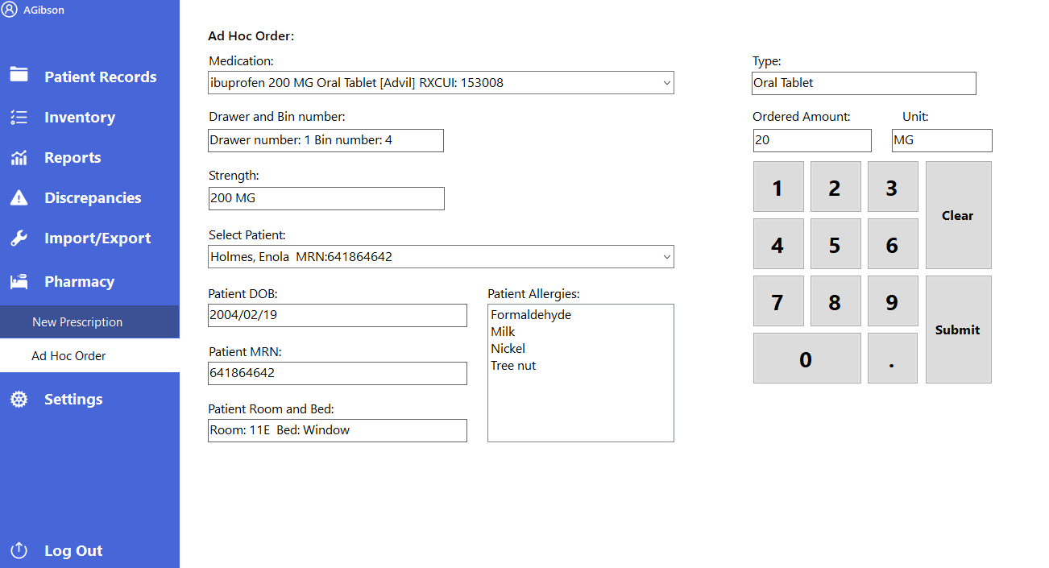

**4**

*Figure 3-30.* This ad hoc dispense screen allows the user to immediately dispense medication to patients. The dispensing process is similar to *Figures 3-7, 3-8, 3-11, 3-12 and 3-13*.

**2**

**3**

**1**

|  |  |  |  |
| --- | --- | --- | --- |
|  |  |  |  |
| 1. Medication Selection: | Use this drop-down menu to select from a list of medications within the cart. | **4. Number Pad:** | Use these buttons to input a number into the text box above and press “**Submit”** to start the medication dispensing process. |
| 2. Ordered Amount and Unit: | Use these text boxes to insert the specified amount within the container and its units. | **5. Physician Selection:** | Use this drop-down menu to select from a list of active physicians. |
| 3. Patient Selection: | Use this drop-down menu to select from a list of active patients. |  |  |



Table 3-21: Figure 3-30 Details

*Figure 3-32.* Appears when Simulation mode is enabled

*Figure 3-31.* Appears when Simulation mode is disabled



# Graphical user interface, application Description automatically generatedSettings: User Settings

**6**

**5**

**3**

**4**

**2**

**1**

*Figure 3-33.* This user settings screen allows the user to edit, add or change a user’s status and search through a list of registered users.

Table 3-22: Figure 3-33 Details

|  |  |  |  |
| --- | --- | --- | --- |
|  |  |  |  |
| 1. Create New User Information: | Use these text fields to insert new user information. | **3. Plus / Minus:** | Use this button ( )to set a user’s record to active or inactive by clicking ✔ or cancel the action by clicking **X.** |
| 2. Search Bar: | Use the search bar to find specific users within the list of registered users. | **5. Permissions:** | Use these radio buttons to select the appropriate access level for the new user. |
| 3. Pencil: | Use this button ( 🖉 ) to change a user’s first name, last name, username, barcode, password, and permissions. | **6. Save User:** | Use this button to create a new user and save the changes made. |

# Settings: Discharge / Admit 🡪 Admit Patient

# 

*Figure 3-34.* This discharge / admit screen allows the user to select a patient and admit a new or previously existing patient.

**4**

**3**

**2**

**1**

Table 3-23: Figure 3-34 Details

|  |  |  |  |
| --- | --- | --- | --- |
|  |  |  |  |
| 1. Admit Patient: | Use these radio buttons to display the admit patient information. | **3. Room and Bed:** | Use this drop-down menu to select from a list of available rooms and beds. |
| 2. Select Patient to Admit: | Use this drop-down menu to select from a list of patients to admit. The patient’s demographic information will be automatically filled in. | **4. Admit:** | Use this button to admit a new or previously existing patient. |

# Settings: Discharge / Admit 🡪 Discharge Patient

*Figure 3-35.* This discharge / admit screen allows user to select a patient and discharge a new or previously existing patient.

**3**

**2**

**1**

Table 3-24: Figure 3-35 Details

|  |  |
| --- | --- |
|  |  |
| 1. Discharge Patient: | Use these radio buttons to display the discharge patient information. |
| 2. Select Patient to Discharge: | Use this drop-down menu to select from a list of patients to discharge. The patient’s demographic information will be automatically filled in. |
| 3. Discharge: | Use this button to discharge a new or previously existing patient. |

# Settings: Edit Rooms / Bed 🡪 Add Room and Bed

*Figure 3-36.* This edit rooms / beds screen allows the user to add a new room and bed into the database.

**4**

**3**

**2**

**1**

|  |  |  |  |
| --- | --- | --- | --- |
|  |  |  |  |
| 1. Add a Room and Bed: | Use these radio buttons to display the add a room and bed information. | **3. Bed Name:** | Use this text box to enter a new bed name. |
| 2. Room Name: | Use this text box to enter a new or existing room name. | **4. Add:** | Use this button to add a room and bed into the database. |

Table 3-25: Figure 3-36 Details

# Settings: Edit Rooms / Bed 🡪 Delete Room or Bed

**1**

**2**

**3**

*Figure 3-37.* This edit rooms / beds screen allows the user to delete a room or bed from the database.

Table 3-26: Figure 3-37 Details

|  |  |
| --- | --- |
|  |  |
| 1. Delete a Room or Bed: | Use this radio button to display the delete a room and bed information. |
| 2. Delete Room: | Use this list box to select a desired room and press delete room. |
| 3. Delete Bed: | Use this list box to select a desired bed and press delete bed. |

# Settings: Admin Settings

**3**

**1**

**4**

**2**

*Figure 3-38.* This admin settings screen allows the user to change the baud rate, com port, and enable or disable simulation mode.

Table 3-27: Figure 3-38 Details

|  |  |  |  |
| --- | --- | --- | --- |
|  |  |  |  |
| 1. Baud rate: | Use this drop-down menu to change the speed at which information is transferred via a serial port.  (Recommended: 115200 baud) | **3. Simulation Mode:** | Use this check box to disable and enable simulation mode.  **Disable** to use the Medcart Automated Dispensing Cabinets.  **Enable** to configure drawers while not connected to the cart. |
| 2. COM Port: | Use this drop-down menu to choose which COM port the computer is communicating with. | **4. Save:** | Use this button to save any changes you have made. |

# Graphical user interface, application Description automatically generatedSettings: Physician Settings

**1**

**4**

**3**

**5**

**2**

*Figure 3-39.* This physician settings screen allows the user to create, edit, change a user’s status and search through a list of registered physicians.

|  |  |  |  |
| --- | --- | --- | --- |
|  |  |  |  |
| 1. Search bar: | Use this search bar to find a specific physician within the list of registered physicians. | **4. Plus/Minus:** | Use this button ( ) to set a physician’s record to active or inactive by clicking ✔ or cancel the action by clicking **X**. |
| 2. Physician Information: | Use these text fields to create and edit a physician’s information. | **5. Save:** | Use this button to save any changes made to the physician’s information. |
| 3. Pencil: | Use this button ( 🖉 ) to edit a physician’s information. |  |  |

Table 3-28: Figure 3-39 Details

# Using the MedServe Software

4

4

***Login:***

1. Double-click on the MedServe icon on your Desktop to start the application.
2. Login by scanning your badge ID or enter a username and password by clicking “**Login with Password.**”

***Dispense Medication to Patient***

1. Navigate to **Patient Records** 🡪 **All Patients** within the MedServe application and select a patient record.
2. Select the medication you want to dispense to the patient under Prescriptions. For an allergy override sign-off, scan/enter your badge ID or click on **“Enter password instead”** to sign off using a username and password.
3. Enter an amount to remove, click **“Enter”** to open a drawer, and take medication from the drawer.
4. Count the quantity of the medication from the drawer and close the drawer. If you’ve forgotten to count the quantity, click the “**Reopen Drawer**” button to reopen the drawer.
5. Enter the quantity of the selected medication from the drawer; if prompted, click “**Submit Count.**”
6. Enter the amount administered to the patient, click “**Submit Count.**”
7. Enter the wasted medication amount. If there is no wasted amount, enter 0.
8. Select a reason for wasting the medication.
9. If a witness sign-off is required, scan your badge ID or click “**Enter Password instead**” to use a username and password.
10. Click “**Submit**” to save this information into the system.

***My Patients***

1. Navigate to **Patient Records** 🡪 **My Patients** within the MedServe application.
2. Click the drop-down menu next to “**Filter**” and select between all active patients or my patients.
3. To assign a patient to yourself, select “**Active Patients**” as a filter and search for the patient. (You may find it helpful to use the search bar at the top and search by name or MRN)
4. Select the “**+**” to the right of the patient’s information to assign them to you. In the filter, to ensure they are assigned to you, choose “**My Patients**” and check if they are listed there.
5. To unassign a patient from yourself, you may filter by either “**Active Patients**” or “**My Patients**” or use the search bar at the top and search by their name or MRN. Once you have found the patient you wish to remove, press the “**-**” sign to the right of the patient’s information.

***Add Patient***

1. Navigate to **Patient Records** 🡪 **Add Patient** within the MedServe application.
2. Enter the first name, middle name, and last name of the desired patient.
3. Select their room from the “**Rooms**” drop-down menu and available beds from the “**Beds**” drop-down menu.
4. Select their sex from the “**Sex**” drop-down menu and then enter their date-of-birth, their height (centimeters), and their weight (kilograms).
5. Enter their street address, city of residence, state of residence from the “**State**” drop-down menu, and zip code.
6. Enter their email address (in the format of *name@domain.org*), then their phone number for contact.
7. Select their primary physician from the “**Primary Physician*”*** drop-down menu.
8. Click “**Save**” to enter this patient into the system.

***Restock Inventory***

1. Navigate to **Inventory** 🡪 **Restock Inventory** within the MedServe application.
2. Choose a report type of controlled, non-controlled, or narcotic medication using the drop-down menu next to “**Report Type.**”
3. Review the medication listed and select and input the updated medication amount for that specific medication under “**New Total.”**
4. Click the ( ) on the right side of the medication to flag that medication record for updating.
5. Click the **“Update Inventory”** button to update all medication bin amounts that have been flagged.

***Configure Inventory***

1. Navigate to **Inventory** 🡪 **Configure Inventory** within the MedServe application.
2. Under “**Drawer Information**” at the top, you may select the button that corresponds to a specific drawer to view its contents.
3. If you wish to remove a medication from a drawer, select the button that corresponds to that drawer, find the drug in the list on the right, and press the trash can icon.
4. If you wish to change the amount of dividers in a drawer, select the button that corresponds to that drawer and choose the amount of dividers you want the drawer to have using the blue up and down arrow buttons next to “**Dividers”** and click the **“Save Changes”** button**.**

***Add Medication to Cart***

1. Navigate to **Inventory** 🡪 **Configure Inventory** within the MedServe application.
2. Press “**Add to Drawer**” on the right side of the window.
3. You may search for the medication by typing in the name of the medication and click enter
4. Select a medication from the drop-down menu under “**Select from List.**”
5. Select whether the medication is a narcotic or a controlled substance by clicking the appropriate checkbox or leave the checkboxes blank for non-narcotic / controlled substances.
6. Enter the medication’s schedule, the medication’s strength, the type of the medication (e.g., oral injection), the barcode of the medication, and its expiration date.
7. Choose a drawer number and bin to place the medication in and the medication’s quantity.
8. Select whether or not the selected medication is a personal medication from the drop-down menu.
9. Enter the amount per container and the units of measurement.
10. Click “**Save**” to add the medication’s information to the software.

***Wasting Medication***

1. Navigate to **Inventory** 🡪 **Waste** within the MedServe application.
2. Select a patient from the “**Select Patient**” drop-down menu.
3. Select a medication from the “**Medication**” drop-down menu.
4. Enter the wasted medication amount. If there is no wasted amount, enter “**0**.”
5. Select a reason for wasting the medication.
6. If a witness sign-off is required, scan your badge ID or click “**Enter Password instead**” to use a username and password.
7. Click “**Submit**” to save this information into the system.

***Reports***

1. Navigate to **Reports** within the MedServe application.
2. Click the drop-down menu next to “**Select Report**” and choose the medical transactions you wish to view, such as “**Wasted Medication.**”
3. Click the “**Generate Report**” button at the top right of the window to view a table of information regarding the selected report.
4. Click **“Export To Excel**” on the top right side of the window to view this information in Microsoft Excel.

***Resolving Discrepancies***

1. Navigate to **Discrepancies** within the MedServe application.
2. Select the discrepancy you wish to resolve. (Clicking on a discrepancy should create a blue highlight) and click on the “**Resolve**” button to resolve a discrepancy.
3. If you do not wish to resolve a discrepancy, click “**Back**.”
4. If you do want to continue resolving a discrepancy, input a reason for resolving the discrepancy and then press “**Resolve.**”

***Importing Database***

1. Navigate to **Import/Export** within the MedServe application and select “**Import Database.**”
2. Locate and select the .db file you would like to import.

***Importing Database as Copy***

1. Navigate to **Import/Export** within the MedServe application and select “**Import Database as Copy.**”
2. Locate and select the .db file you would like to copy and import.

***Exporting Database***

1. Navigate to **Import/Export** within the MedServe application and select “**Export Database.”**
2. Name and choose a file location to export and save the current database.

***Creating Data to Import***

1. See Appendix A for more details.

***Ordering Prescriptions***

1. Navigate to **Pharmacy** 🡪**New Prescriptions** within the MedServe application.
2. Select the patient from the “**Patient Name**” drop-down menu. This process should autofill the patient’s date of birth.
3. Select the medication from the “**Medication**” drop-down menu. This process should autofill the type and strength.
4. Enter the amount you wish to prescribe and the unit of measurement.
5. Select the hourly frequency from the “**Frequency**” drop-down menu.
6. Select the physician that is ordering the medication from the “**Ordered By**” drop-down menu.
7. Click “**Order Prescription.**”

***Ad Hoc Order***

1. Navigate to **Pharmacy** 🡪 **Ad Hoc Order** within the MedServe application.
2. Select a medication and a patient for the dispensing process.
3. Select the physician that is ordering the medication from the “**Ordered By**” drop-down menu.
4. Enter an ordered amount and its unit of measurement and click “**Submit Order.**”
5. For an allergy override sign-off, scan/enter your badge ID or click on **“Enter password instead”** to sign off using a username and password.
6. Enter an amount to remove, click **“Enter”** to open a drawer, and take medication from the drawer.
7. Count the quantity of the medication from the drawer and close the drawer. If you’ve forgotten to count the quantity, click the “**Reopen Drawer**” button to reopen the drawer.
8. Enter the quantity of the selected medication from the drawer; if prompted, click “**Submit Count.**”
9. Enter the amount administered to the patient, click “**Submit Count.**”
10. Enter the wasted medication amount. If there is no wasted amount, enter 0.
11. Select a reason for wasting the medication.
12. If a witness sign-off is required, scan your badge ID or click “**Enter Password instead**” to use a username and password.
13. Click “**Submit**” to save this information into the system.

***User Settings***

1. Navigate to **Settings** 🡪 **User Settings** within the MedServe application.
2. If you wish to edit an existing user, find the user in the list of “**Registered Users**” and click the pencil (🖉).
3. Change any information about the user you wish to modify under the “**Editing User**” header.
4. Click “**Save**” to save your changes or “**Cancel**” to stop editing.
5. To create a new user, enter the user’s first name, last name, username, barcode (view this (🛈) for more details), password (view this (🛈) for more details) under “**Create New User.**”
6. Re-type the password for confirmation and select the permission level for the new user.
7. Click “**Save User**” to enter this user into the system.
8. To make a user **active** or **inactive**, search for the user you wish to change in the “Registered Users” list and click the “**+/-** “icon.
9. If the user is currently active, click the "✔ “to make the user inactive. If they are currently inactive, clicking"✔ “will make the user active. Click “**X**” to cancel the action.

***Discharge / Admit Patient***

1. Navigate to **Settings** 🡪 **Discharge / Admit** within the MedServe application.
2. Select the correct button corresponding to whether you wish to **admit** a patient or **discharge** a patient.
3. If you are admitting a patient, select a patient from the drop-down menu, select a room and bed from the “Room and Bed” drop-down menu and click the “**Admit**” button.
4. If you are discharging a patient, select a patient from the drop-down menu and click the “**Discharge**” button.

***Edit Rooms / Beds***

1. Navigate to **Settings** 🡪 **Edit Rooms / Beds** within the MedServe application.
2. Select the correct button corresponding to whether you wish to **add a room and bed** or **delete a room or bed**.
3. If you chose to **add a room and bed**, you must enter at least a single character into both the “**Room Name**” and “**Bed Name**” boxes to reveal the “**Add**” button.
4. If you have entered at least one character for each box and the information is correct, click the “**Add**” button to save the data into the system.
5. To delete a room, select the room to delete and press “**Delete Room**.”
6. To delete a bed, select the room the bed is located in, choose the bed under “**Bed Name,**” and click “**Delete Bed**.”

***Checking COM port***

1. Open **Device Manager** andclick on **View** in the menu bar, and select **Show hidden devices**.
2. Locate **Ports (COM & LPT)** in the list and check for the COM ports by expanding.
3. Verify the COM port in the **Device Manager** matches what is displayed in the **Settings** 🡪 **Admin Settings** within the MedServe application.

***Simulation Mode***

Disable: | Enable:



1. Navigate to **Settings** 🡪**Admin Settings** within the MedServe application to enable or disable simulation mode.
2. Disable simulation mode to use MedDispense Automated Dispensing Cabinets when dispensing and adding medication to the drawers.
3. Enable simulation mode to use a visual representation of the MedDispense Automated Dispensing Cabinets when dispensing and adding medication to the drawers.

***Baud Rate***

1. Navigate to **Settings** 🡪**Admin Settings** within the MedServe application to adjust the baud rate.
2. Set the baud rate to the recommended 115200 baud.

***Physician Settings***

1. Navigate to **Settings** 🡪 **Physician Settings** within the MedServe application.
2. If you wish to edit an existing physician, select or search from a list of registered physicians and click the pencil (🖉).
3. Change any information about the physician you wish to modify under the “**Editing Physician**” header.
4. Click “**Save**” to save your changes or “**Cancel**” to stop editing.
5. To create a new physician, enter the physician’s first name and last name under “**Create New Physician.**”
6. Select the physician’s credentials under the “**Credentials**” drop-down menu.
7. Enter the physician’s phone number and fax number.
8. Enter the physician’s street address, city, state of residence from the “**State**” drop-down menu and zip code.
9. Click “**Save**” to enter this physician into the system.
10. To make a physician **active** or **inactive**, find the physician you wish to change in the “**Physicians**” list and click the “**+/-** “icon.
11. If the physician is currently active, click the "✔“to make the physician inactive. If they are currently inactive, clicking "✔ “will make the physician active. Click “**X**” to cancel the action.

***Logout***

1. Double-click on the MedServe icon on your Desktop to start the application.
2. Login by scanning your badge ID or enter a username and password by clicking “**Login with Password.**”
3. Navigate to the bottom left of the application and click the “**Logout**” button.

|  |  |
| --- | --- |
| Permissions | Access Level |
| Nurse: | Login. All Patients. My Patients. Add Patient. Waste. Reports. Discharge / Admit . Edit Rooms / Beds. Log out |
| Supervisor: | Login. All Patients. My Patients. Add Patient . Restock Inventory . Configure Inventory . Waste. Reports . Discrepancies. Import / Export. New Prescription. Ad Hoc Order. User Settings. Discharge / Admit . Edit Rooms / Beds. Physician Settings. Log out |
| Administrator | Login. All Patients. My Patients. Add Patient . Restock Inventory . Configure Inventory . Waste. Reports . Discrepancies. Import / Export. New Prescription. Ad Hoc Order. User Settings. Discharge / Admit . Edit Rooms / Beds. Physician Settings. Admin Settings. Log out |

Troubleshooting and Supporting Documents

5

# **Additional Support Documents**

This Additional Support Documents section aims to provide users with weblinks to software and some additional information to run the MedServe application successfully.

# **RxNav Drug Interaction**

* RxNorm software is information is available at <https://rxnav.nlm.nih.gov/RxNormAPIs.html>
* Drug Interaction API information is available at <https://rxnav.nlm.nih.gov/InteractionAPIs.html>
* RxNav-in-a-Box software is available for download at <https://rxnav.nlm.nih.gov/RxNav-in-a-Box.html>
* Navigating RxNorm drug information is available at <https://mor.nlm.nih.gov/RxNav/>

# **Office 365**

* Office 365 is available for download at <https://setup.office.com/downloadoffice/>
* Office 365 download instructions are available at <https://support.microsoft.com/en-us/office/download-and-install-or-reinstall-microsoft-365-or-office-2019-on-a-pc-or-mac-4414eaaf-0478-48be-9c42-23adc4716658>

# **Schedule**

* Schedule information is available at <https://medshadow.org/drug-classifications-schedule-ii-iii-iv-v/>

# **Allergy Severity**

* Allergy Severity information is available at <https://www.mayocliniclabs.com/test-catalog/Clinical+and+Interpretive/82910>

# **Troubleshooting**

This Troubleshooting section aims to help users with problems that might occur within the MedServe application.

Table 5-1 General Problems

|  |  |  |
| --- | --- | --- |
| Problem | Cause | Solution |
| Forgot my password | Misplaced or forgotten password to MedServe account | Ask a user with supervisor or admin access to change your password or login with your badge |
| Can’t type numbers into the textbox | NumLock is enabled on the keyboard | Disable NumLock on the keyboard |
| Cart drawers do not open when dispensing medication | Power to the cart was interrupted | 1. Check the ensure the power switch to the MedDispensing Automatic Cabinets is turned on.  2. Check the power cable to the wall. |
|  | Serial cable loose or missing from the docking station | Plug the serial cable into the docking station. |
|  | MedServe application is in Simulation mode | Login as an administrator and navigate to **Settings** 🡪 **Admin Settings** touncheck simulation mode and save changes. |
| Allergy already exist for this patient notification | Adding the same allergy name with a different allergy type | Edit the existing allergy name and change its allergy type. |

Table 5-2 Problems with the MedServe software

|  |  |  |
| --- | --- | --- |
| Problem | Cause | Solution |
| Application loads with no data inside | No active database attached to the software | 1. Navigate to Import/Export and import a database.  2. Delete config. app from the program file path **C:\Users\Public\Public Documents\MedServe**  and reboot the MedServe application. |
| Application Freezes | Too many tasks are running in the background | Check within task manager by pressing the **Windows key** 🡪 **type “Task Manager”** 🡪 **Click Open** and end the MedServe application. |
| Communication between the computer and cart is slow | Baud rate transfer speed | Login as an administrator and navigate to **Settings** 🡪 **Admin Settings** to adjust the baud rate speed. |

Table 5-3 Errors

|  |  |  |
| --- | --- | --- |
| Problem | Cause | Solution |
| Can’t retrieve drug information from NIH | Network Connection | Check network connection and cables, then try again. |
| System error: The port “COM” does not exist | Connecting to wrong COM port | Navigate to **Device Manager** and verify COM port.Login as an administrator within the MedServe application, navigate to “**Admin Settings”** and change the COM port to match the computer. |

Appendix A: Importing Data

6

This Importing Data section aims to help the user with importing data to the MedServe application. The importation of data should be imported in the following order: **users, physicians, rooms, and then patients**. Please create each record in the specified order below. A tab delimiter separates each piece of data, and you have the option to produce this data in Microsoft Excel and export it as a .txt file.

Note: If you do not have Office 365 installed, please see page 43 for the installation links.

**Creating User data within Excel workbook:**

1. Open Microsoft Excel and create a blank workbook.
2. Insert the appropriate data in each column as seen below:
3. **Username:** blackDahlia123
4. **Password:** 1LoveFlow3rs
5. **User_First_Name:** Elizabeth
6. **User_Last_Name:** Holmes
7. **Barcode:** jsjfd343fs32
8. **Admin Flag_Flag:** 0 (0 for nurse, 1 for admin)
9. 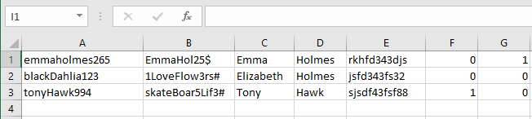**Supervisor_Flag:** 0 (0 for nurse, 1 for supervisor)

*Figure 6-1*

1. **Save Workbook:** Navigate to **File** 🡪 **Save as** 🡪 **Browse** 🡪 **Choose a file location** 🡪 **Create a filename** 🡪 **Click Save**
2. **Save .txt file:** Navigate to **File** 🡪 **Export** 🡪 **Change File Type** 🡪 **Double-click Text (Tab delimited) (*.txt)** 🡪 **Choose a file location** 🡪 **Create a filename** 🡪 **Click Save**
3. Double-click on the MedServe icon on your Desktop to start the application.
4. Login by scanning your badge ID or enter a username and password by clicking “**Login with Password.**”
5. Navigate to **Import / Export** with the MedServe application and select “**Import Records”**
6. Select “**User Record**” and click “**Select File**”
7. Navigate to the folder that the .txt file was created and click “**Open**”
8. 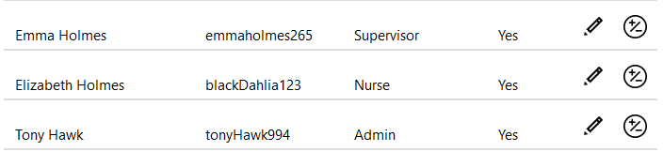Navigate to **Settings** 🡪 **User Settings** with the MedServe application to view a list of your recent user imports, as seen below.

*Figure 6-2*

***User Data Order:***

Username, Password, User_First_Name, User_Last_Name, Barcode, Admin_Flag , Supervisor_Flag

Table 6-1 Format for Users

|  |  |  |  |
| --- | --- | --- | --- |
|  |  |  |  |
| 1. Username | has to be a unique series of letters and numbers.  *example:* LeoCohen329 | **5. Barcode** | has to be a series of letters and numbers with a minimum length of 12 to 24 characters.  *example:* JXP9+t8ucjPxV7g |
| 2. Password | has to be a series of letters and numbers with AT LEAST 8 characters. There must be at least 1 uppercase character, 1 lowercase character, 1 number, and 1 special character (!@#$%^&*).  *example:* FamousBlueRaincoat71# | **6. Admin_Flag** | has to be a 1 for an admin user; otherwise, a 0 for a nurse.  *example:*  1 |
| 3. User_First_Name | has to be a series of letters and numbers.  *example:* Leonard | **7. Supervisor_Flag** | has to be a 1 for a supervisor or charge nurse; otherwise, 0 for a nurse.  *example: 0* |
| 4. User_Last_Name | has to be a series of letters and numbers.  *example:* Cohen |  |  |

***Room Data Order:***

Room_ID, Bed_Name

Table 6-4 Format for Rooms

|  |  |  |  |
| --- | --- | --- | --- |
|  |  |  |  |
| 1. Room_ID | has to be a series of letters or numbers.  *example:* 215A | **2. Bed_Name** | has to be a series of letters or numbers.  *example:* B3 |

***Physician Data Order:***

|  |  |  |  |
| --- | --- | --- | --- |
|  |  |  |  |
| 1. Physician_First_Name | has to be a series of letters and numbers.  *example:* Sofia | **7. Physician_Address** | has to be a series of letters and numbers.  *example:* 556 Chistopol |
| 2. Physician_Middle_Name | has to be a series of letters and numbers.  *example: Camila* | **8. Physician_City** | has to be a series of letters.  *example: Taylor* |
| 3. Physician_Last_Name | has to be a series of letters and numbers.  *example:* Garcia | **9. Physician_State** | has to be a 2-character string of an existing U.S. state.  *example:* MI |
| 4. Physician_Credentials | has to be a 2-character string.  *example: MD* | **10. Physician_Zip_Code** | has to be a 5-digit number.  *example:* 48460 |
| 5. Physician_Phone_Number | has to be a series of numbers in the format of XXX-XXX-XXX.  *example:* 123-456-7890 | **11. Active_Flag** | has to be a 1 for an active physician; otherwise, a 0 for inactive.  *example: 1* |
| 6. Physician_Fax_Number | has to be a series of numbers in the format of XXX-XXX-XXX.  *example:* 123-456-7890 |  |  |

Physician_First_Name, Physician_Middle_Name, Physician_Last_Nam, Physician_Credentials, Physician_Phone_Number, Physician_Fax_Number, Physician_Address, Physician_City, Physician_State, Physician_Zip_Code, Active_Flag

Table 6-3 Format for Physician

***Patient Data Order:***

MRN_Number, Barcode, Patient_First_Name, Patient_Middle_Name, Patient_Last_Name, Date_of_Birth, Sex, Height, Weight, Address, City, State, Email_Address, Zip_Code, Phone_Number, Primary_Physician_ID

Table 6-2 Format for Patients

|  |  |  |  |
| --- | --- | --- | --- |
|  |  |  |  |
| 1. MRN_Number | has to be a unique identification number.  *example:* 278769641 | **9. Address** | has to be a series of letters and special characters.  *example:* 5632 Van Nuys Blvd. |
| 2. Barcode | has to be a series of letters and numbers with a min length of 12 to 24 characters.  *example:* 6fOVToceutMzN | **10. City** | has to be a series of letters and special characters.  *example:* Hollywood |
| 3. Patient_First_Name | has to be a series of letters and special characters.  *example:* John | **11. State** | has to be a 2-character string of an existing U.S. state.  *example:* CA |
| 4. Patient_Middle_Name | has to be a series of letters and special characters.  *example:* Howard | **12. Email_Address** | has to be in the format of a standard email address.  *example:* carperjohn@gmail.com |
| 5. Patient_Last_Name | has to be a series of letters and special characters.  *example:* Carpenter | **13. Zip_Code** | has to be a 5-digit number.  *example:* 33004 |
| 6. Date_of_Birth | has to be a valid birth date.  *example:* 01/16/1948 | **14. Phone_Number** | has to be a series of numbers in the format of XXX-XXX-XXX.  *example:* 123-456-7890 |
| 7. Height | has to be a number value. (centimeters)  *example:* 183 | **15. Primary_Physician_ID** | has to be a unique identification number.  *example:* 33 |
| 8. Weight | has to be a number value. (kilograms)  *example:* 80 |  |  |

Appendix B: ByteScout Barcode Generator

7

Steps for running the ByteScout Barcode Generator:

1. Locate the **ByteScout Barcode Generator** application on the Desktop or search for it using the Windows key.
2. Double click on the **ByteScout Barcode Generator** application to start the program.
3. 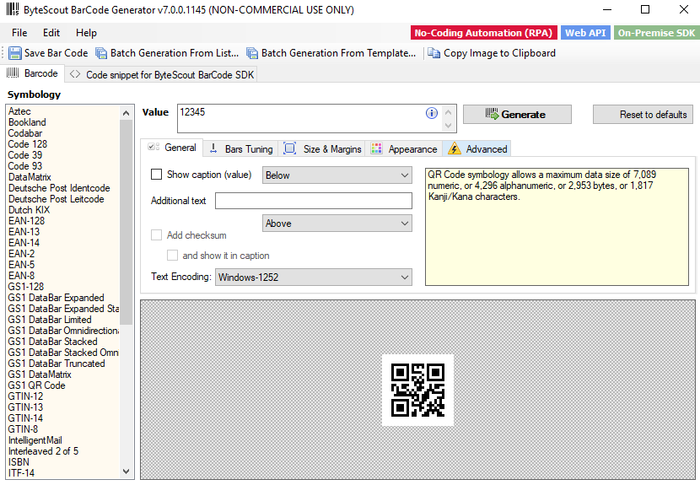Confirm what is shown on your screen matches what is in *Figure 7-1*.

*Figure 7-1*

# **Creating a QR Code / Barcode in Barcode Generator**

1. Select the “**QR code**” or “**PDF417**” (barcode) option from the Symbology list.
2. Input into the **Value** textbox a series of letters and numbers with a minimum of 12 to 24 characters.
3. Click “**Generate**” to create your unique QR code or barcode.
4. Click “**Save Bar Code**”
5. Choose a destination to store your QR code or barcode.
6. Print the QR codes or barcodes via Microsoft Word or a photo application.

**4**

**1**

**2**

**3**

*Figure 7-2*

# **Creating Multiple Barcodes / QR Code in Barcode Generator**

1. Select the “**QR code**” or “**PDF417**” (barcode) option from the Symbology list.
2. Click “**Batch Generation from List…”** to create multiple barcodes / QR codes.
3. Input into the **Value** textbox a series of letters and numbers with a minimum length of 12 to 24 characters.
4. Click “**Generate multiple barcodes**” to create your unique barcodes / QR codes.
5. Choose a destination to store your QR codes or barcodes.
6. Print the QR codes or barcodes via Microsoft Word or a photo application.

**2**

**1**

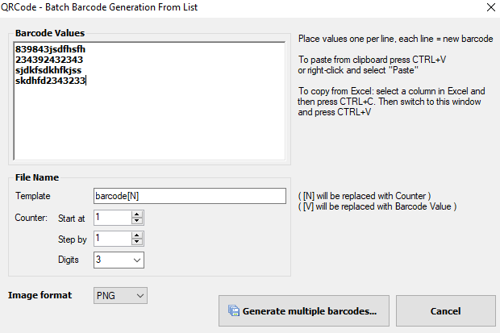

**3**

*Figure 7-3*

**4**

*Figure 7-4*

8

Glossary

8

The terms and definitions listed below may be defined primarily by their relation/purpose within the software and not their generally accepted definitions.

# **Medical Vocabulary**

1. **Ad Hoc Dispense** – an immediate dispense of a medication to a patient.
2. **Allergy Severity** – a scale for determining how severe the allergic reaction a patient has to a substance.
3. **Badge** – an identification card used to display information about a person typically includes a first and last name, job title, name of their place of work, an identification number, expiration date, and a barcode.
4. **Discharge** – changing the status of a patient from active to inactive.
5. **Discrepancy** – an issue that arises from the difference between the system count and the actual count.
6. **Dispense** – the action of removing medication from the cart to give to a patient.
7. **MRN** (Medical Record Number) – a number assigned to a patient that serves as a form of identification.
8. **NIH** (National Institutes of Health) – the primary agency of the United States government responsible for biomedical and public health research
9. **RxNav-in-a-Box** [Software] - provides users with a locally installable version of [RxNav](https://rxnav.nlm.nih.gov/RxNavDoc.html), [RxClass](https://rxnav.nlm.nih.gov/RxClassIntro.html), and RESTful companion APIs, including [RxNorm](https://rxnav.nlm.nih.gov/RxNormAPIs.html), [Prescribable](https://rxnav.nlm.nih.gov/PrescribableAPIs.html), [RxTerms](https://rxnav.nlm.nih.gov/RxTermsAPIs.html), [RxClass](https://rxnav.nlm.nih.gov/RxClassAPIs.html), and [drug-drug interactions](https://rxnav.nlm.nih.gov/InteractionAPIs.html).
10. **RxNorm** [Web Service] **–** provides normalized names for clinical drugs and links its names to many of the drug vocabularies commonly used in pharmacy.
11. **Schedule** – the organization of drugs into groups based on the risk of abuse or harm.
12. **Waste** – discarding part of or all of a medication.
13. **Witness Sign-off –** the requirement for another person or “witness” to accept the submission of a wasted medication.

# **Technological Vocabulary**

1. **API** (Application Programming Interface) – an interface that defines and interacts with multiple software applications.
2. **Baud rate** – the rate at which information is transferred through a communication channel.
3. **ByteScout Barcode** **Generator** [Software] – software used to create different barcodes or QR codes and saves them as images.
4. **COM** **Port** (Communication Port) – a port that allows a serial device to connect to a computer.
5. **Database** – a data structure that is used for the storage and organization of information.
6. **Display** – a device that allows a user to view information from a computer visually. Typically referred to as a monitor.
7. **Docker** [Software] – operating system-level virtualization software allows users to develop, ship, and run applications.
8. **Excel** [Software] – spreadsheet software allows users to create information, graphs and performs calculations.
9. **Graphics** **Card** – a computer hardware piece tasked with rendering images and displaying them to a monitor.
10. **LPT** **Port** – a port used for connecting peripherals, also referred to as a parallel port.
11. **Office 365** [Software]– a subscription service that offers users a series of Microsoft Office product line applications.
12. **Operating** **System** – software that allows a computer to complete essential functions like running applications and controlling peripheral devices.
13. **Processor** – computer hardware that performs operations like arithmetic, logic, and forms of input/output based on a series of instructions hardcoded into the unit, also referred to as a CPU.
14. **QR** **code** (Quick Response Code) – a two-dimensional barcode that contains information about an item.
15. **Scanner** ­– used to read various types of barcodes and QR codes.
16. **Simulation** **Mode** – used to enable software functionality while not connected to a cart.
17. **SQLite** [Software] – a database management system (DBMS) allows a single database connection to access multiple database files simultaneously.
18. **Storage** – used to store data long-term. Typically comes in the form of a hard drive.

# Index

9

A

Active 36, 49

Ad Hoc Order 27, 39, 42

Admin 3, 6, 33, 41, 42, 44, 45, 46, 48

Allergy 15, 43, 44, 54

API 20, 43, 55

B

Badge 2, 7, 8, 54

Barcode 4, 46, 48, 50, 51, 52, 53

Baud rate 33, 45, 55

Bed 29, 31, 32, 40, 41, 48

ByteScout Barcode Generator 51, 55

C

COM port 33, 41, 45, 55

D

Database 6, 25, 38, 55

Discharge 2, 29, 30, 40, 42, 54

Discrepancies 2, 23, 24, 38, 42

Discrepancy 23, 24, 38

Dispense 2, 5, 35, 54

Divider 19

Docker 5, 55

Drawer 12, 13, 19, 20, 35, 37, 39

E

Edit 3, 10, 31, 32, 40, 42, 44

Excel 22, 38, 46, 55

Export 2, 22, 25, 38, 42, 44, 46, 47

F

File 6, 25, 46, 47

Frequency 26, 39

G

Graphics Card 4, 55

I

Import 2, 25, 38, 42, 44, 47

L

Login 2, 6, 7, 8, 35, 42, 44, 45, 47

Logout 42

M

Medication……. 11, 12, 13, 14, 20, 21, 23, 26, 27, 35, 37, 38, 39

MRN 9, 16, 36, 50, 54

N

NIH 20, 45, 54

O

Office 365 43, 46, 55

Operating System 4, 55

Order 26, 39, 48, 49, 50

P

Password 2, 6, 7, 8, 35, 37, 39, 42, 46, 47, 48

Patient…… 2, 9, 10, 11, 12, 13, 14, 15, 16, 17, 20, 21, 26, 27, 29, 30, 35, 36, 37, 39, 40, 42, 50

Pencil 15, 28, 34

Pharmacy 2, 26, 27, 39

Physician 3, 34, 36, 41, 42, 49, 50

Prescription 26, 39, 42

Processor 4, 55

Q

QR code 8, 52, 53, 55

R

Record 2, 17, 25, 47, 54

Report 18, 22, 38

Room 29, 31, 32, 40, 48

RxNav-in-a-Box 43, 54

RxNorm 43, 54

S

Scanner 4, 55

Schedule 43, 54

Simulation 33, 41, 44, 55

SQLite 5, 55

Storage 4, 6, 55

T

Trash 10, 15, 19

U

User 6, 28, 39, 40, 42, 46, 47, 48

Username 2, 8, 46, 48

W

Waste 2, 14, 21, 37, 42, 54

Witness Sign-off 14, 21, 35, 37, 54